1. **Perform Sharpening of Image using unsharp masking.**

**Aim:**

To perform sharpening of image using unsharp masking python.

**Code:**

import cv2

import numpy as np

img = cv2.imread("C:\\Users\\prith\\Documents\\CV\\cvimage.jpg")

gray = cv2.cvtColor(img, cv2.COLOR_BGR2GRAY)

laplacian_kernel = np.array([[0, 1, 0], [1, -4, 1], [0, 1, 0]])

laplacian = cv2.filter2D(gray, -1, laplacian_kernel)

sharpened = cv2.add(gray, laplacian)

cv2.imshow('Original Grayscale', gray)

cv2.imshow('Sharpened Image', sharpened)

cv2.waitKey(0)

cv2.destroyAllWindows()

**Input:**

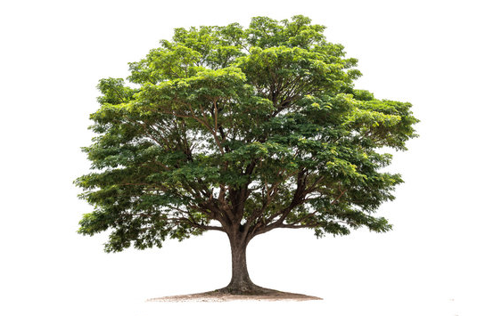

**Output:**

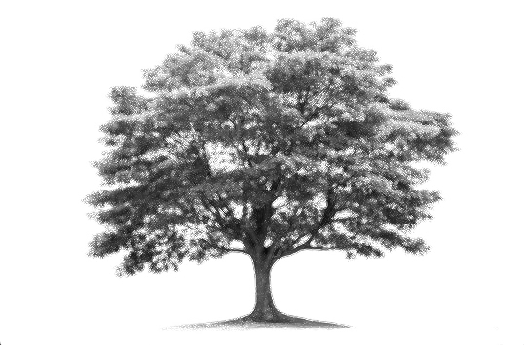

**Result:**

The python code to perform sharpening of image using unsharp masking has been executed successfully.